New York Society of Physical Medicine & Rehabilitation Founded 1921
October 2011

Executive Board President - Dr. Susan Stickevers
Vice President - Dr. Joe Rothenberg
Co-Vice President - Dr. Ruth Alejandro Treasurer - Dr. Irvin Kotkin Secretary - Dr. Marni Hillinger
Chair of the Executive Committee - Dr. Michelle Stern
Legislative Council - Dr. Tamar Kessel
Legislative members - Dr. Irvin Kotkin, Dr. Naheed Van der Walle Program Director – Dr. Emerald Lin
Resident Council:
President – Dr. Sarah Khan
Vice President – Dr. Mously Le Blanc
Membership Coordinators – Dr. Isaac Darko and Dr. Steve Massimi
Workshop Chair – Dr. Elizabeth Nguyen
Workshop Co-Chair – Dr. Andrew Toy
Community Events Chair – Dr. Alexander Martinez
Community Events Co-Chair – Dr. Libi Galmer
Information Technology Chair – Dr. Sagar Parikh
Research and Scholarly Activity Coordinator – Dr. Raj Telhan
Medical Student Outreach – Dr. Marni Hillinger, Co-Chair: Dr. Anne Marie Gallagher

Job Fair – April 4, 2012, 6-8pm Please come and find out about amazing opportunities in your area! Many employers and fellowships will be represented. If you are an employer or fellowship director and would like to be featured in the Job Fair, please email nysocietyofpmr@gmail.com for details.

Residents’ Bowl – May 2, 2012 New York’s finest residents in Physical Medicine and Rehabilitation will compete at the annual NYSPMR Resident Bowl! Join us as representatives from various PM&R residency programs throughout New York battle it out “game-show style” to determine who will have the honors of victory! All are invited to attend and observe the competition which will likely be entertaining as well as provide an educational review on a variety of topics pertinent to the field of Physical Medicine and Rehabilitation. Congratulations again to the reigning champions, Stony Brook. Attendings can submit multiple-choice style questions to Dr. Ruth Alejandro at alejanjrl@netzero.net and Dr. Susan Stickevers at Susan.Stickevers@va.gov
Residents’ Night – June 6, 2012 The educational year will conclude in June with the annual NYSPMR Resident’s Night. Submissions of original research abstracts or case reports (which have not been previously published or presented) are now being accepted and reviewed. This is an excellent opportunity for resident authors to submit their original works to present and obtain official recognition. To be considered for presentation please email your original abstract to Susan.Stickevers@va.gov
NYC Marathon – November 6th We are looking for volunteers to assist in the medical tents for the New York City Marathon. This is a great opportunity to volunteer while practicing physical examination skills. If interested please email nysocietyofpmr@gmail.com for details.

UPCOMING WORKSHOPS Look for upcoming workshops in Botulinum Toxin (Wednesday Oct 19th), Musculoskeletal Ultrasound (Saturday Dec 3) and Prosthetics and Orthotics TBD
"NYSPMR Resident/Fellow Musculoskeletal Ultrasound and Injection Workshop" Saturday December 3, 2011 8am-5pm Columbia University Medical Center Neurological Institute 710 W 168th St 8th floor, South Classroom New York, NY 10032-3726 Please contact: moa9024@nyp.org to register
WORKSHOPS ARE FREE FOR NYSPMR MEMBERS! BECOME A MEMBER NOW!
Discounted Resident/Fellow Group Membership Rate: $10 membership fee when 5 or more residents/fellows register together. (See Below for Membership Information)
Membership Information: The New York Society of Physical Medicine and Rehabilitation (NYSPMR) is a non-profit educational organization dedicated to the advancement of the specialty of Physical Medicine and Rehabilitation (PM&R) and to providing for our members educational, networking and legislative opportunities. Our Society consists of New York State physicians practicing or interested in the field of PM&R. We need your support to help us for our legislative and educational initiatives.
To join the NYSPMR and to help support our current activities, please contact: Valerie Davis, 12 East 41st Street, 15th floor. New York, N.Y. 10017 Tel: 212-684-4670 or visit our website at https://sites.google.com/site/newyorksocietyorpmr/home/2011-2012-membership-information-and-annual-dues Membership dues can be paid by check to Valerie Davis

CME Credits We would like to express our gratitude to the Hospital for Special Surgery for providing our CME accreditation this year as well as for allowing us the use of their conference center for the past 5 years. Please visit the HSS website to learn about further educational activities that are being offered by the hospital. http://www.hss.org/cme.asp.
To obtain CME credits please go to the following website and register http://www.hss.edu/cme.asp.
If you have any questions, please contact the person below as our CME credits is through HSS.

Tonie Augurt, LCSW Professional Education Program Coordinator, Accreditation and Compliance Hospital for Special Surgery 535 East 70th Street New York, NY10021 p: 212.606.1547 f: 212.734.3833 AugurtA@hss.edu

ADVERTISING OPPORTNITIES Advertise your company or products on the NYSPMR website. This is a low-cost, high-visibility opportunity to reach out to numerous physiatrists in the state of New York. Please contact nysocietyofpmr@gmail.com for details.

TAKE A SURVEY Tell us how we are doing! Please take the following survey in order to help improve our monthly lecture series and for feedback http://www.surveymonkey.com/s/XGGLYF3

OSTEOPATHIC MANIPULATIVE TECHNIQUE GAINING INTEREST

The Introduction to Osteopathic Manipulative Techniques Workshop took place at New York University (NYU) Rusk Institute of Rehabilitation Medicine on May 25, 2011. This workshop was organized in collaboration with the New York Society of Physical Medicine and Rehabilitation and the NYU Osteopathic Manipulative Medicine (OMM) Interest Group spearheaded by two NYU physiatrist residents, Jackie Beltran, DO and Justin Mendoza, DO. The lectures were given by Sarah Khan, DO and the focus of the course was to provide a basic introductory discourse on the fundamentals and uses of osteopathic manipulative medicine.
Sarah Khan, a Mount Sinai resident, decided to coordinate this workshop because of her passionate belief in osteopathic medicine. According to Dr. Khan, osteopathic manipulative medicine enhances one’s palpation skills, which is key as a physiatrist to accurately diagnose musculoskeletal conditions. The philosophy of osteopathic medicine focuses on the interrelationship of structure and function, and using one’s hands to diagnose and treat structural problems to promote the body’s natural ability to heal itself. Furthermore as a modality, it is useful for not only simply treating musculoskeletal disorders, but also for preventing new structural restrictions that cause musculoskeletal pain.
Fellow colleagues, Justin Mendoza, DO and Aaron Shiu, DO, assisted Dr. Khan in proctoring the hands-on workshop. The hands-on portion of the workshop provided a unique opportunity for the attendees to practice palpation and basic treatment techniques. This interactive portion was designed for those at all skill levels to enhance their level of expertise.
The NYU OMM Interest Group typically meets on the first Saturday of every month to review a topic in osteopathic manipulative medicine. Regardless of whether you have had little or no experience in osteopathic manipulation or if you’re just interested in practicing or further developing your osteopathic skills, these meetings are an excellent opportunity for those of all skill levels.
Be sure check out the New York Society of Physical Medicine & Rehabilitation webpage at https://sites.google.com/site/newyorksocietyorpmr/ for information regarding the next OMM interest group meeting.
~Sarah Khan, D.O.
SPECIAL OLYMPICS

The Special Olympics of New York serves over 50,000 athletes, making it the largest athletic organization for persons with disabilities in the United States and the sixth largest program in the world. Its mission is to provide year-round sports training and athletic competition for all children and adults with physical and intellectual disabilities giving them opportunities to strive towards their greatest athletic potential, build confidence and build a positive self-image, which carries into the classroom, home, and workplace.
As physiatrists, it is a great privilege to have a role in the realization of the physical and functional goals of our patients. By becoming involved in the Special Olympics, we not only support an amazing organization, but also have the opportunity to use our knowledge of musculoskeletal and rehabilitative medicine to assist with any issues or injuries that may arise during the games.
The 2011 Special Olympics Regional Metro Tournament was held on June 4, 2011 at Queens College in Flushing, NY. The day began with a parade introducing all the regional teams from throughout the five boroughs, Long Island, and Hudson Valley competing in the day’s events. Members of NYSPMR proudly volunteered by performing general medical health screening, providing first aid care for injuries and by enthusiastically cheering on the participants. Events included 100 and 200 meter dash, softball throw, and weight lifting among other sporting events. 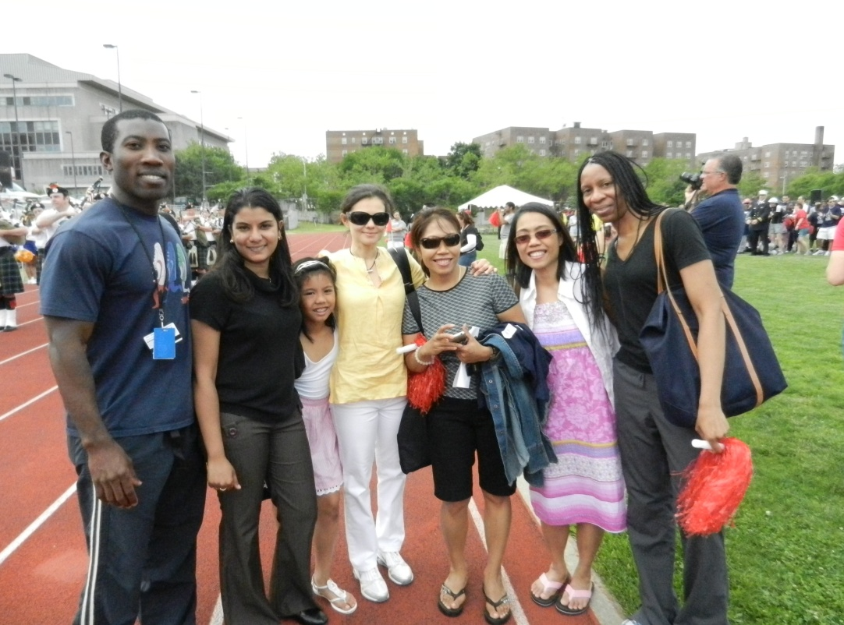 NYSPMR Volunteers: Isaac Darko MD, Sarah Khan DO, Raj Capoor MD, Anya Myers DO
We were initially introduced to the Special Olympics by a resident colleague, Isaac Darko, from Mount Sinai. After having volunteered at several games, Darko wanted to give other PM&R residents the opportunity to participate in such a rewarding experience. After attending several events with Darko, we noticed a strong interest from not only residents, but also from medical student as well. Medical students from several schools volunteered at the games, but had little knowledge of the basic musculoskeletal exam. It was at this point that we decided to put together a structured workshop where we would focus on a different joint or limb at each sporting event.
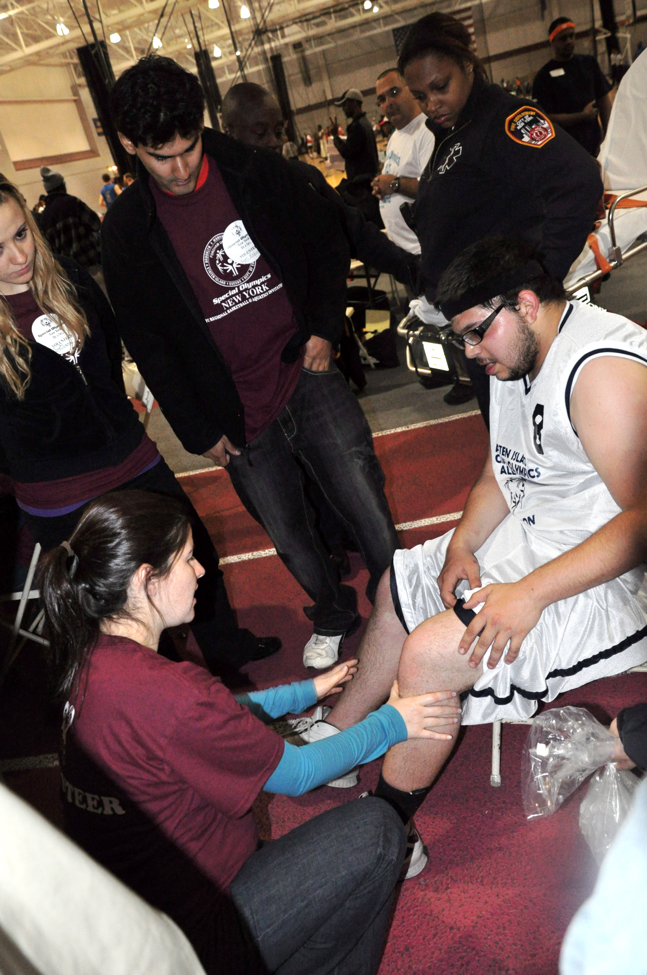 Libi Galmer, DO teaching a group of medical students how to examine the knee
We have recruited student and resident volunteers, as well as attendings who were more than thrilled to become involved with this project. Dr. Ruth Alejandro of Blythedale Children's Hospital enthusiastically participated in the workshop and continued to share pearls of wisdom with the students during down time. After examining each other's ankles and shoulders, the medical students were able to practice their newly learned physical examination skills on some of the athletes. It was an honor to be an integral part of the largest event in New York, with over 500 athletes competing in basketball and swimming. We had a great student and resident turn out.
The Special Olympics musculoskeletal workshops continue to generate noteworthy interest from students and residents from all over the tri-state area. We look forward to continuing this tradition and welcome anyone interested in participating in future events. Please email nysocietyofpmr@gmail.com for more information.
~Libi Galmer DO, Sarah Khan D.O.
A NEW AND EXCITING USE FOR BOTULINUM TOXIN
A privately eccentrically decorated room in the Crosby Hotel was filled with 15 residents eager to learn more about cervical dystonia. The residents in attendance represented New York University, Mount Sinai and New York Presbyterian Cornell and Columbia residency programs.
The NYSPMR sponsored Cervical Dystonia Management workshop took place on April 20, 2011 at the Crosby Hotel and was coordinated by Mously Le Blanc, MD, a resident from New York Presbyterian Cornell and Columbia Hospitals. Her personal area of interest is cancer rehabilitation. While most residents nationally receive extremely limited to no exposure to cancer rehabilitation, Le Blanc is personally invested in promoting this new and growing subspecialty of PM&R. Cervical dystonia is a well-documented complication of radical neck dissections, a surgery commonly performed on patients with malignant head and neck cancers. In practice, botulinum toxin injections to carefully selected neck muscles, commonly the sternocleidomastoid and scalenes, provide significant pain relief to these patients.
Dr. Heakyung Kim, an internationally renowned spasticity specialist, presented a memorable lecture as the residents enjoyed a 3-course meal provided by Allergan. Dr. Kim, an eloquent and humorous public speaker, delivered a well organized lecture with numerous patient photographs and video clips effectively displaying images from before and after botulinum toxin treatment. Many of the residents were amazed by the dramatic effects of this treatment intervention. The lecture discussed indications, method of action of the medication, and provided real patient clinical vignettes. The lecturer reviewed anatomy including the functions and innervation of several neck muscles as well as focused on key landmarks to identify and structures to avoid when performing an injection. Moreover, Dr. Kim described how injections can be performed with either electromyography or ultrasound guidance for patient safety.
After discussing injection techniques in the lecture, the residents had the unique opportunity of practicing their injection technique on the Elvis models. The models, with adjustable neck positions, were attached to screens that displayed the muscle in which the needle was inserted. As residents practiced injecting the models, the screen provided crucial feedback essential to learning proper and accurate injection technique and necessary patient positioning. There were several additional Elvis models displaying the bony and muscular anatomy of the cervical region for review.
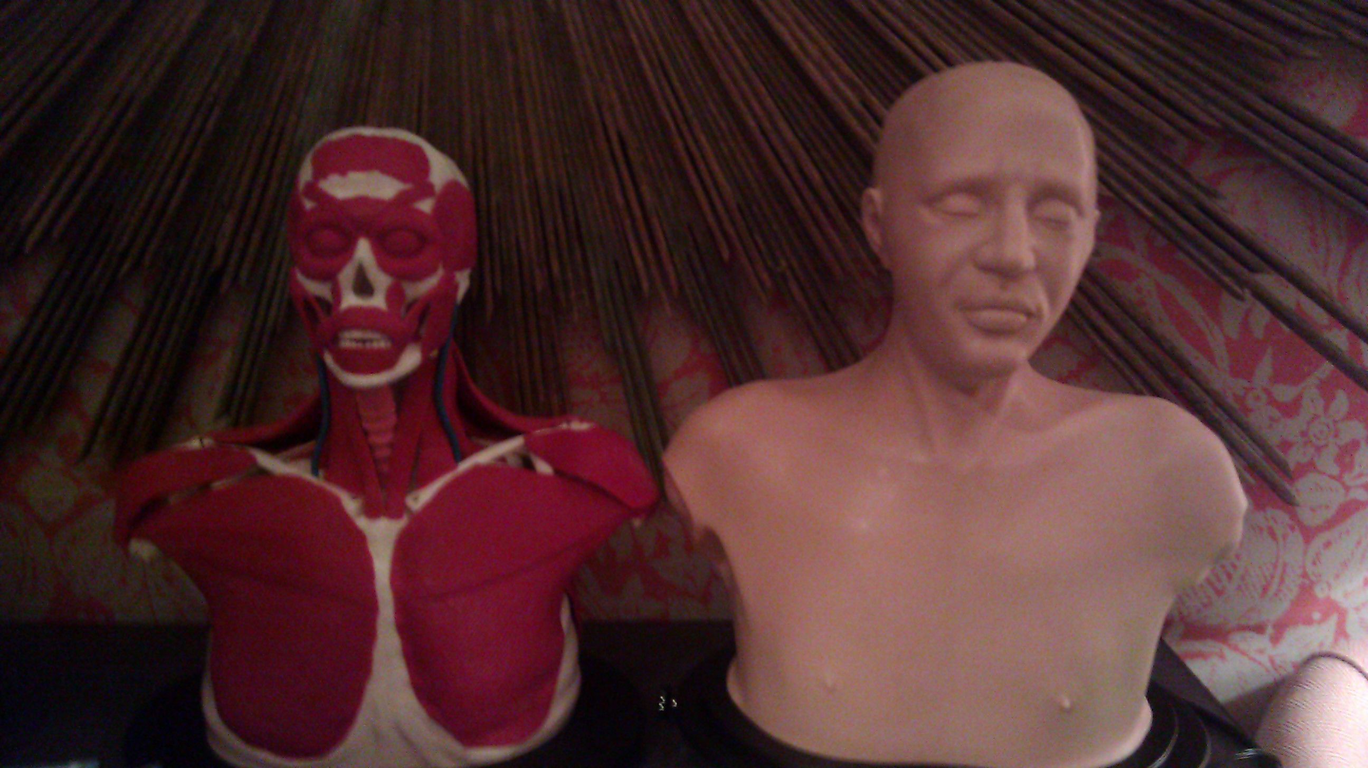 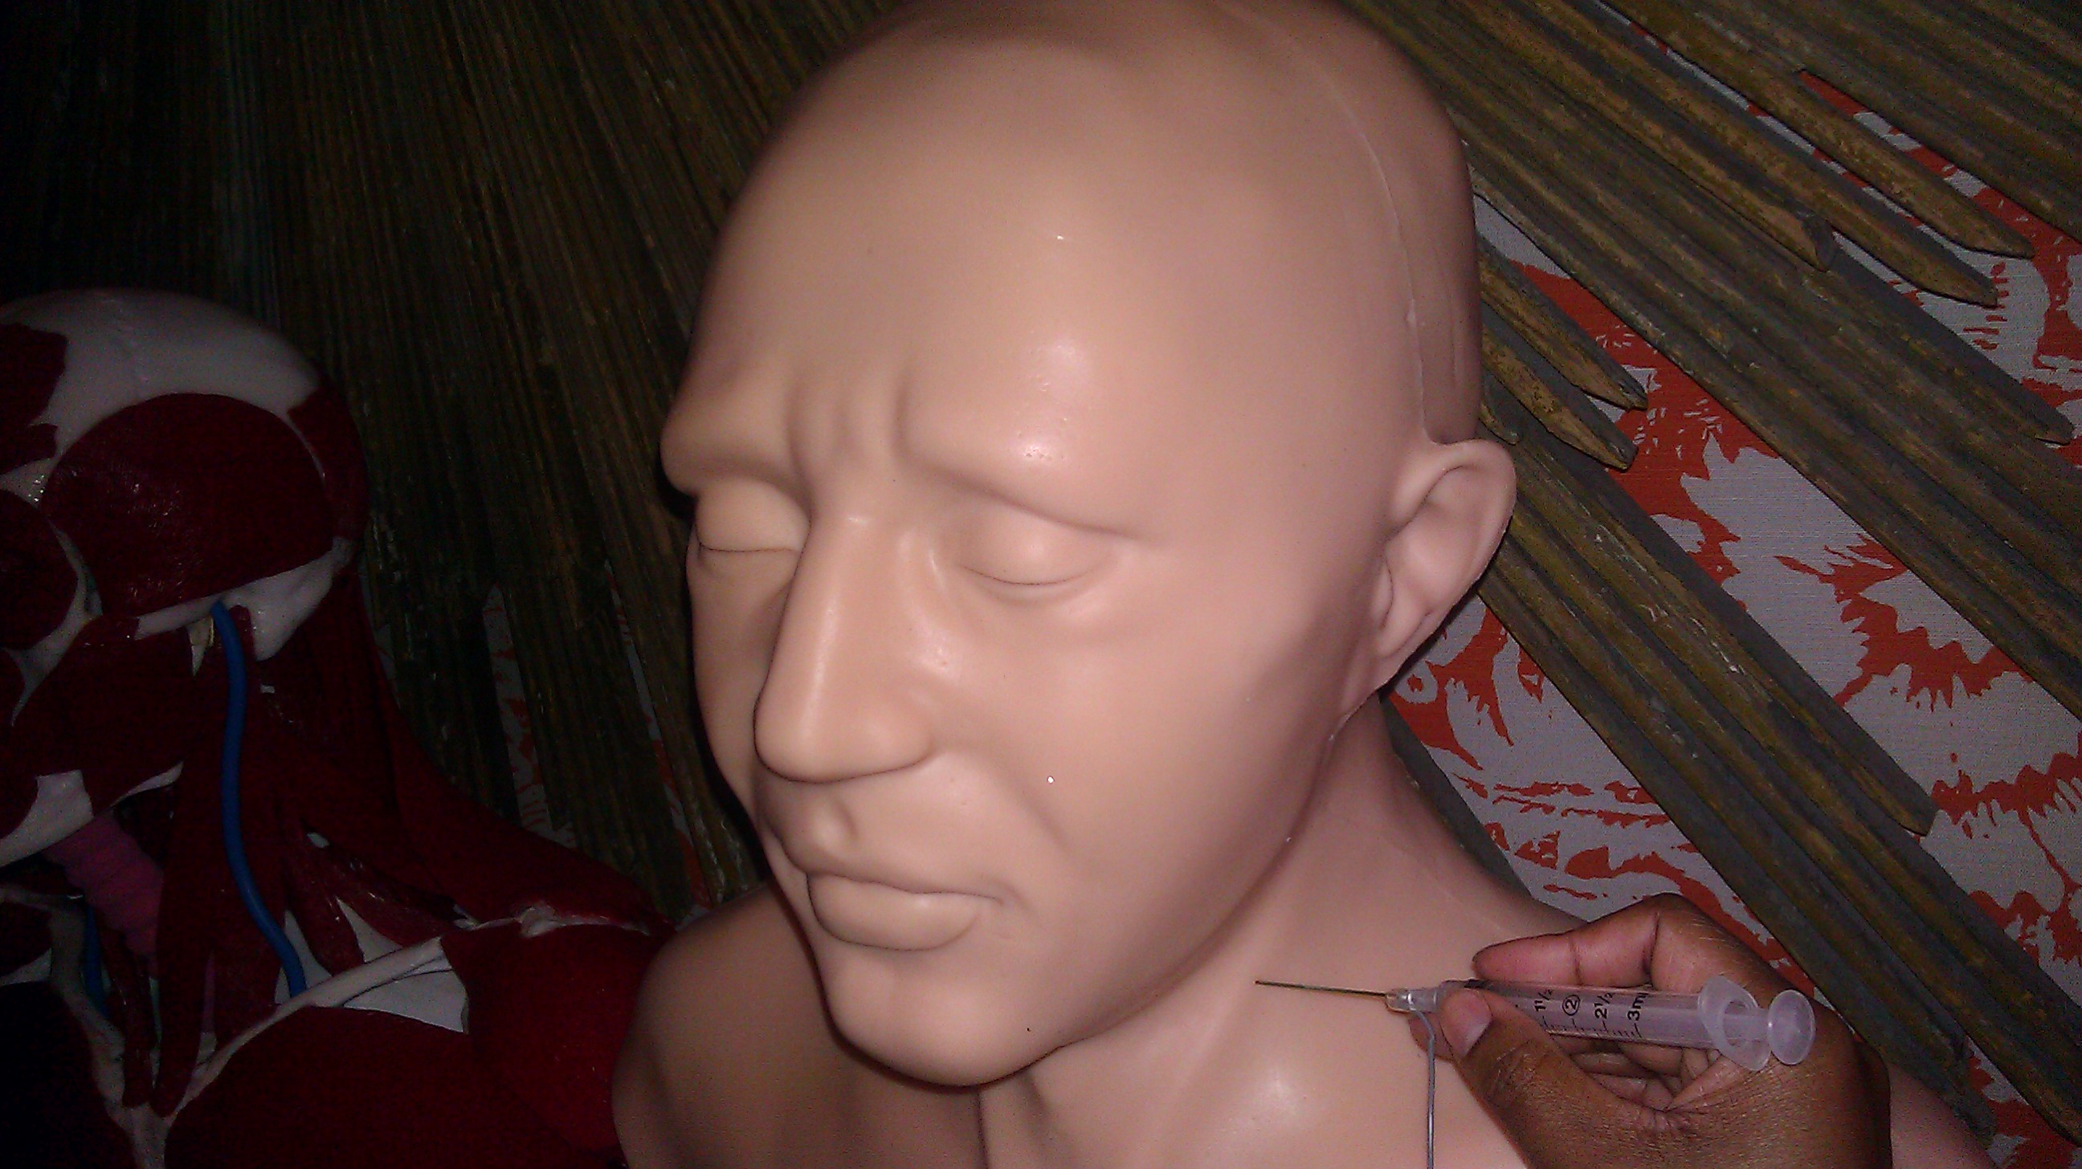 Various Elvis models that were used to teach anatomy and practice injections
The feedback from the event was overwhelmingly positive. Some of the comments from the attendees are listed below. “The speaker discussed a relevant topic. She is very familiar with the product uses”; “Excellent format to learn about botox and how I can implement and integrate it into my entire practice”; “A truly memorable program”; “I loved it!”; “One of the best workshops I’ve attended”; “Extremely educational and fun”.
Emerald Lin, MD practices her injection technique with the Elvis model
Please join us for our next Botulinum Toxin Workshop on Wednesday October 19, 2011. This workshop will focus on Migraine Headaches. Please email nysocietyofpmr@gmail.com for more information.
~Mously Le Blanc, MD

PHYSICAL MEDICINE AND REHABILITATION STUDENT SERIES OFF WITH A BANG
As a medical student, I attended several of the New York Society of Physical Medicine and Rehabilitation monthly meetings. I was impressed by the fact that residents and attendings from across the state of New York collaborated on a regular basis to learn and exchange ideas. However, I also remembered wishing that more medical students were in attendance, since I wanted to meet my peers and potential future colleagues.

Now as a resident member of the Executive Board of the NYSPMR, I have the opportunity to create that very forum for medical students who are interested in a career in physiatry. Through collaboration with my fellow resident, Dr. Marni Hillinger, we were able to formulate a curriculum for the medical students that mirrors the monthly NYSPMR meetings and specifically addresses their interests.

The NYSPMR Student Lecture series kicked off on May 25th at New York Presbyterian Hospital Weill Cornell with a wonderful lecture given by Dr. Anne Ambrose from the Mount Sinai Department of Rehabilitation. Her engaging talk highlighted important issues pertaining to life as an academic physician and the intricacies of conducting rehabilitative research abroad. Our second event took place at Weill Cornell on July 12th and featured Dr. Andre Panagos from Spine and Sports Medicine of New York. His dynamic lecture outlined pertinent functional anatomy and pathology related to the spine. Medical students from across the New York area enjoyed these events.

Our next lecture series will take place this fall. We hope to continue to provide medical students with an accessible platform to further their education and gain insight into the field of physiatry.
To get involved as a mentor please email nysocietyofpmr@gmail.com for more information.
~Annemarie Gallagher, MD, Marni Hillinger, MD

